Name ___________________________________________________________________
1

Date __________________________ Class _____________________________________

- LISTENING ASSESSMENT: AN AUTOMATED MESSAGE
Read and listen to the questions. Then listen to the automated telephone message and answer the questions. Circle the correct answer.

- What is the caller’s name?
  - Peter Piper
  - Alicia Applebee
  - Sam Gonzalez
  - Dr. Oz

- What is his telephone number?
  - 555-23-1597
  - 92173
  - 619-429-5555
  - 858-588-8888

- What is his date of birth?
  - 11/18/42
  - 25/12/88
  - 03/01/55
  - 12/25/88

- What is his marital status?
  - Single
  - Married
  - Divorced
  - Widowed

- What is his address?
  - 911 Emergency Road
  - 91910
  - 1312 Lorna Street
  - Chula Vista

- What is his height?
  - 200 pounds
  - 6 feet 4 inches
  - 4 feet 6 inches
  - 62 kilos

- VOCABULARY
Fill in the blanks.

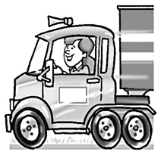
- A _______________ needs a license.

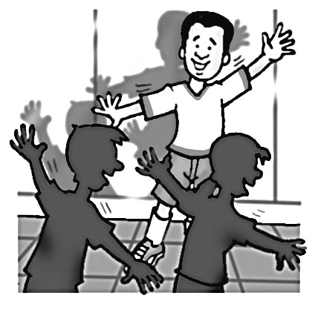

- An _______________ gives dance lessons.

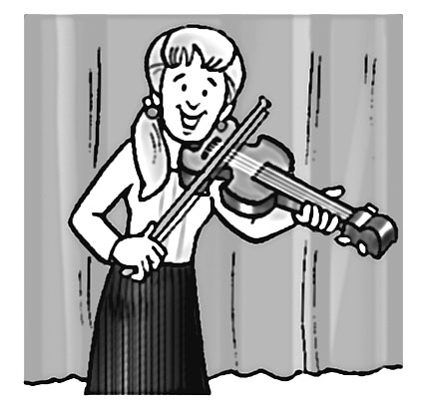
- The _______________ likes to play classical music.

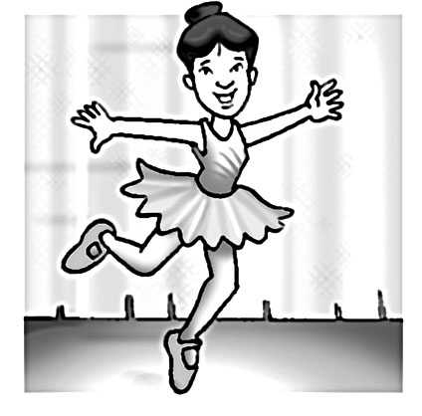
- A _______________ practices ballet.
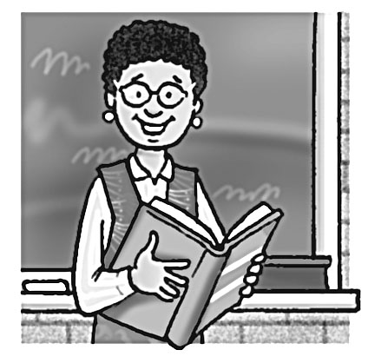

- A _______________ teaches English.

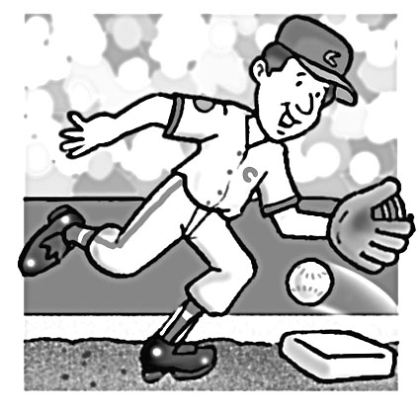
- A _______________ is paid for playing baseball.

- SUBJECT AND OBJECT PRONOUNS
Circle the correct answer.

Example:
_____ calls _____ every Sunday afternoon.
- She . . . she
- Her . . . she
- She . . . her
- We . . . her

- An _______________ gives dance lessons. _____ talking about _____ grandchildren.
  - Their . . . their
  - We're . . . our
  - She . . . her
  - He’s . . . he’s

- _____ write to _____ cousin in Miami every week.
  - We’re . . . our
  - She . . . her
  - I . . . my
  - They . . . they’re

- She _____ swim very well. She _____ a good swimmer.
  - isn't . . . doesn't
  - doesn't . . . is
  - not . . . isn’t
  - doesn’t . . . isn’t

- _____ coach tells _____ he’s a good soccer player.
  - His . . . him
  - His . . . his
  - Hers . . . her
  - Her . . . she

- _____ play tennis very often. _____ very busy.
  - We don't . . . We don't be
  - She doesn't . . . She
  - We don't . . . We're
  - We . . . We’ll

- ______teacher tells _______ they are good students.
  - There . . . they
  - Their . . . them
  - They’re . . . us
  - Our . . . she

- _____ brother likes ______ ESL class.
  - Mine . . . he
  - My . . . his
  - I . . . mine
  - He . . . her

- _____ instructor tells _____ they play violin better than anyone else in school.
  - He . . . me
  - Mine . . . he
  - You . . . your
  - Their . . . them

- _____ shouting at _____ employees.
  - He’s . . . his
  - His . . . he’s
  - Me . . . my
  - You . . . you

- _____mother cooks turkey for _____ every Thanksgiving.
  - They’re . . . them
  - There . . . we
  - Our…us
  - Me . . . I

- Mary is arguing with _____ landlord. _____ argues with him every month.
  - his . . . Him
  - its . . . It
  - she . . . She
  - her . . . She

- _____ the best ballet dancers in _____ school.
  - They’re . . . their
  - There . . . our
  - Their . . . they
  - Were . . . the
- GRAMMAR IN CONTEXT: SMALL TALK AT WORK
Choose the correct answer to complete the conversations. Circle the correct answer.

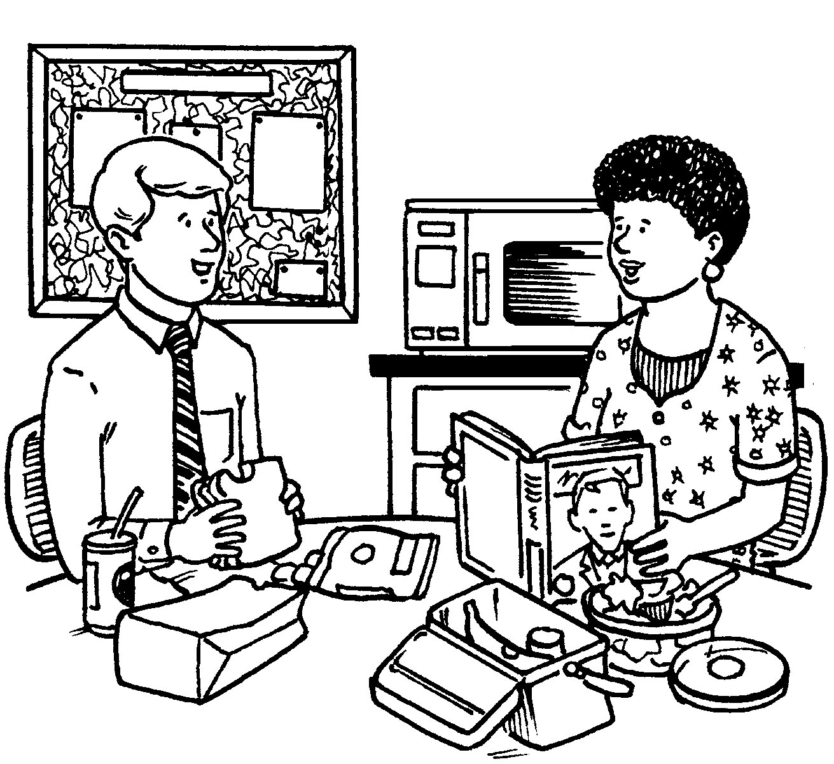
- What are you _____?
  - reading
  - looking
  - read
  - look

- _____ a book about the president.
  - I read
  - I’m reading
  - I watch
  - I’m watching

- Do you _____ biographies?
  - reading
  - like to
  - like to read
  - liking

- Yes. _____ them whenever I can.
  - I read
  - I’m reading
  - I like
  - I like to
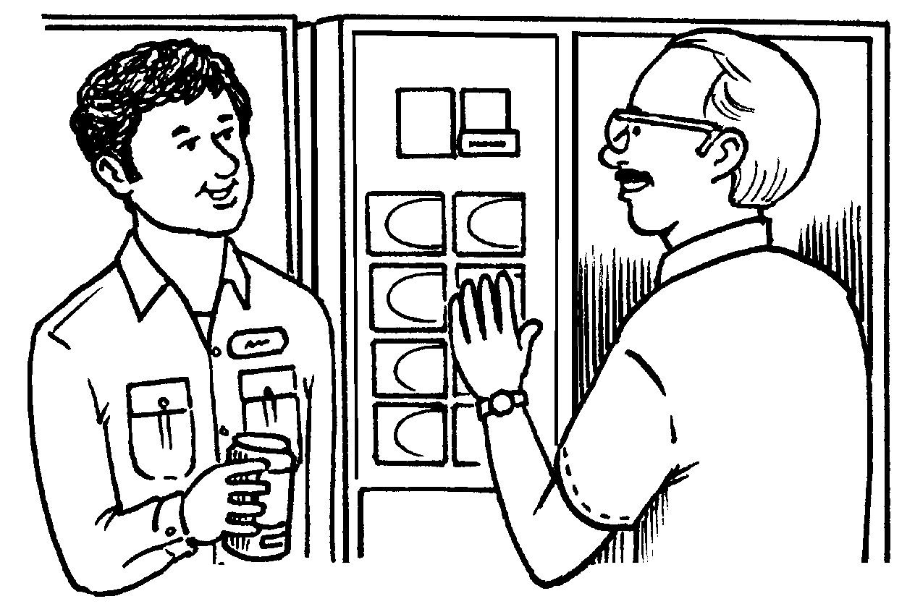

- _____ swim?
  - You like
  - You like to
  - You do like to
  - Do you like to

- No. _____ a very good swimmer.
  - I don’t
  - I’m not
  - You’re
  - You aren’t

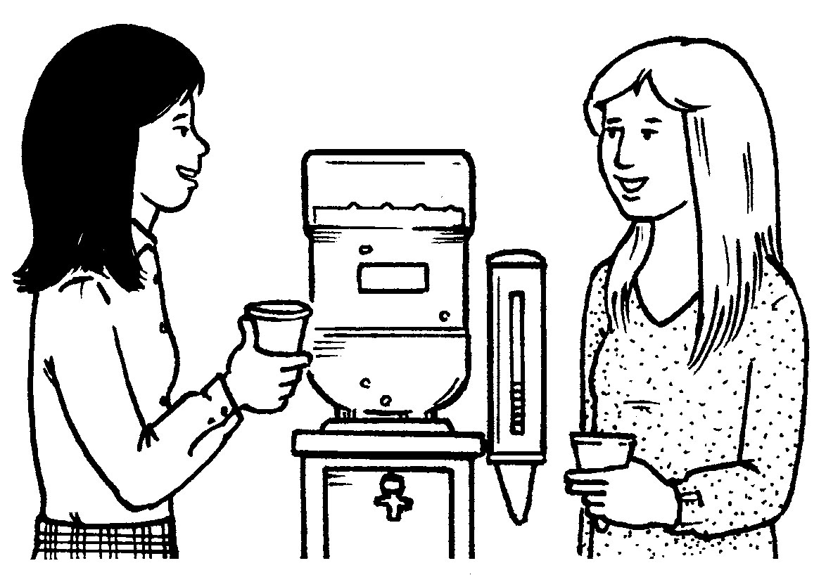
- _____ exercise?
  - You often
  - How often you
  - How often do you
  - Do you how often

- I exercise _____.
  - three times
  - three times a week
  - three weeks
  - every
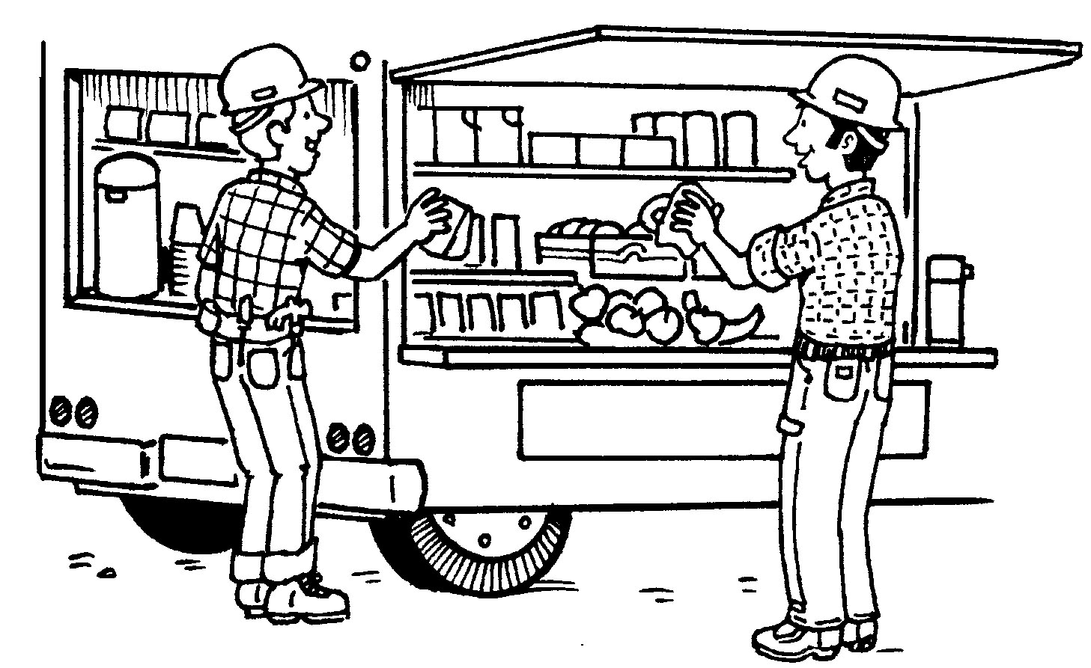

- What do you like to do _____?
  - in your free time
  - in your time
  - in your free
  - when your free time

- I like to _____.
  - tennis player
  - tennis
  - playing tennis
  - play tennis

- WRITING ASSESSMENT: PERSONAL INFORMATION FORM
Fill in the blanks with the correct information.

Name: (35)__________________________________________________________________________________
Address: (36)___________________________________ City: (37)____________ State: (38)___ Zip: (39)______
Social Security Number: (40)______________________ Country of Origin: (41)___________________________
Telephone: (42)___________________ E-Mail: (43)___________________ Date of Birth: (44)______________
Height: (45)_________ Eye Color: (46)___________ Hair Color: (47)__________ Marital Status: (48)_________
Family Members in Household (Name -- Relationship):
(49)_________________________________________(50)___________________________________________
NAME RELATIONSHIP

